Project - High Level Design

on
Telecomm Tutor Bot

Course Name: Generative AI

Institution Name: MEDICAPS UNIVERSITY
– Datagami Skill Based Course

Student Name(s) & Enrolment Number(s):
Sr no | Student Name | Enrolment Number
1. | Ankit Yadav | EN22CS301136
2. | Anshuman Geete | EN22CS301160
3. | Arti Jain | EN22CS301206
4. | Atisha Jain | EN22CS301235
5. | Avani Sharma | EN22CS301239
6. | Ishana Hatodiya | EN23CS3L1011

Group Name: 07D2
Project Number: GAI-19
Industry Mentor Name:
University Mentor Name: Dr. Hemlata Patel
Academic Year: 2022-2026

Table of Contents
- Introduction.
  - Scope of the document.
  - Intended Audience
  - System overview.
- System Design.
  - Application Design
  - Process Flow.
  - Information Flow.
  - Components Design
  - Key Design Considerations
  - API Catalogue.
- Data Design.
  - Data Model
  - Data Access Mechanism
  - Data Retention Policies
  - Data Migration
- Interfaces
- State and Session Management
- Caching
- Non-Functional Requirements
  - Security Aspects
  - Performance Aspects
- References

1. Introduction.
The Telecomm Tutor is an advanced AI-driven educational and assessment system developed specifically for the telecommunications domain. The primary purpose of this system is to evaluate users’ understanding of telecomm plan details and provide intelligent, context-aware feedback that strengthens conceptual clarity.
Telecommunication plans are complex and include multiple variables such as data limits, voice benefits, SMS allowances, roaming charges, validity periods, Fair Usage Policies (FUP), add-on packs, billing cycles, and regulatory conditions. Traditional training methods often rely on static content and basic multiple-choice tests, which do not effectively measure deep conceptual understanding.
The Telecomm Tutor Bot addresses this limitation by integrating a Large Language Model (LLM) capable of:
- Understanding natural language responses
- Evaluating conceptual correctness
- Identifying partial knowledge
- Detecting misunderstandings
- Providing detailed contextual explanations
Rather than simply indicating whether an answer is correct or incorrect, the system explains why it is correct or incorrect, helping users bridge knowledge gaps. This creates a personalized and adaptive learning loop, making the system suitable for telecomm training programs, academic learning, and professional upskilling.
The solution combines AI-based reasoning with domain-specific telecomm knowledge, transforming assessments into an intelligent tutoring experience.
1.1 Scope of the document
This document provides a detailed description of the Telecomm Tutor Bot system, outlining its purpose, structure, and intended usage. The scope includes:

1. Functional Scope
- Interactive telecomm-based assessments
- Natural language response evaluation
- AI-powered contextual explanation generation
- Personalized adaptive questioning
- Performance-based learning reinforcement

2. Technical Scope
- Integration of a Large Language Model (LLM)
- High-level system architecture overview
- Data flow and workflow explanation
- Security and reliability considerations
- Personalization logic design

3. Operational Scope
- Deployment overview (conceptual)
- User interaction process
- Use in training and academic environments
This document does not include detailed implementation code or low-level API specifications but focuses on system-level understanding, design logic, and operational behavior.

1.2 Intended Audience
This document is designed for multiple stakeholders involved in the development, deployment, and utilization of the Telecomm Tutor Bot.

1. Project Stakeholders
To understand the purpose, value, and impact of the system.

2. Software Developers & System Architects
To gain clarity on:
- System workflow
- AI integration approach
- Personalization mechanisms
- Component interactions

3. AI/ML Engineers
To understand:
- LLM-based evaluation logic
- Prompt engineering strategies
- Concept gap detection mechanisms

4. Telecom Domain Experts
To review:
- Accuracy of plan-related assessments
- Industry relevance
- Domain alignment

5. Training Managers & Instructors
To evaluate:
- Suitability for employee training
- Performance tracking capabilities
- Adaptive learning features

6. Academic Evaluators
To assess:
- Educational effectiveness
- Innovation in AI-based tutoring
- System design and scalability

1.3 System Overview
The Telecomm Tutor Bot is an interactive chatbot-based learning system that uses AI to simulate a smart telecomm tutor. The system operates through a structured workflow that ensures assessment, feedback, and reinforcement.

Core Workflow
- Topic Selection
- User selects a telecom plan or concept (e.g., prepaid plans, roaming charges, FUP rules, add-ons).
- Question Generation
- The system generates a targeted question based on selected plan details.
- Questions may test interpretation, comparison, pricing logic, or policy understanding.
- User Response

- User provides a natural language answer.
- The system accepts descriptive responses, not just multiple-choice selections.

- LLM-Based Evaluation
  - The Large Language Model:
- Interprets the answer contextually
- Compares it with actual plan specifications
- Determines correctness level (Correct / Partially Correct / Incorrect)
- Identifies specific conceptual gaps
- Contextual Feedback Generation
  - The system explains:
- Why the answer is incorrect
- What the correct interpretation should be
- Relevant telecom rules or conditions
- Feedback is educational, not just corrective.
- Personalization Logic
- The system tracks weak areas.
- Generates follow-up questions targeting misunderstood topics.
- Reinforces concepts until mastery is achieved.

2. System Design
The System Design of the Telecomm Tutor defines the architectural structure, application behavior, internal workflows, data interactions, and integration interfaces. The design ensures scalability, modularity, maintainability, and accurate AI-driven evaluation for telecomm-specific learning.
The system follows a modular and layered architecture, separating presentation, business logic, AI processing, and data management layers. This ensures flexibility for future enhancements and easy integration with enterprise training platforms.

2.1 Application Design
The application is designed as a conversational AI system with the following architectural layers:

1. Presentation Layer
- Web or mobile-based chatbot interface

- Handles user interaction
- Displays questions, explanations, and scores
- Accepts natural language responses

2. Application Layer (Business Logic)
- Manages quiz sessions
- Controls question generation logic
- Tracks user performance
- Implements personalization rules
- Coordinates LLM evaluation requests

3. AI Evaluation Layer
- Integrates with a Large Language Model (LLM)
- Performs contextual answer evaluation
- Generates explanations
- Detects conceptual gaps

4. Data Layer
- Telecom plan database
- Question templates
- User performance records
- Analytics and reporting data

Design Characteristics
- Modular architecture
- Scalable LLM integration
- Stateless AI calls with stateful session tracking
- Secure data storage

UseCase Diagram:
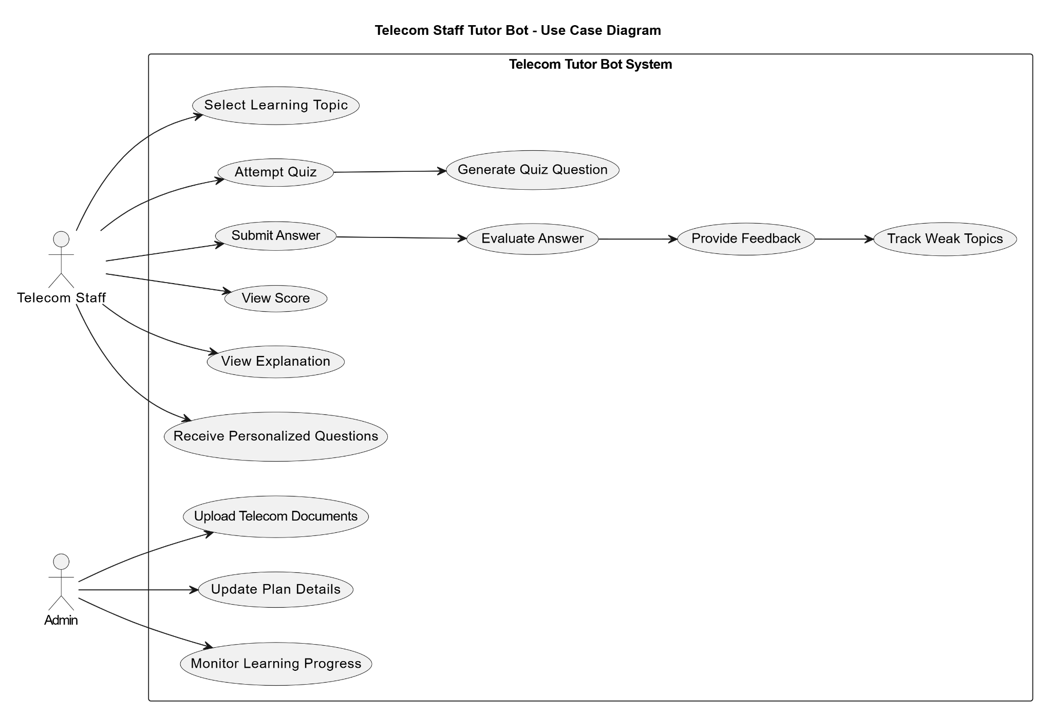

2.2 Process Flow
The system follows a structured operational process:

Step 1: User Authentication (Optional)
- User logs in or starts session.

Step 2: Topic / Plan Selection
- User selects telecom plan or learning module.

Step 3: Question Generation
- System retrieves plan details.
- Generates question dynamically (rule-based or AI-assisted).

Step 4: User Response Submission
- User submits natural language answer.

Step 5: LLM Evaluation
- Prompt constructed with:
  - Plan details
  - Correct answer reference
  - User response
- LLM evaluates conceptual correctness.

Step 6: Feedback Generation
- System generates:
  - Score
  - Correct answer
  - Detailed explanation
  - Concept clarification

Step 7: Personalization Trigger
- Weak areas identified.
- Adaptive follow-up questions generated.

Step 8: Performance Recording
- User response and analysis stored.
- Progress metrics updated.

WorkFlowDiagram: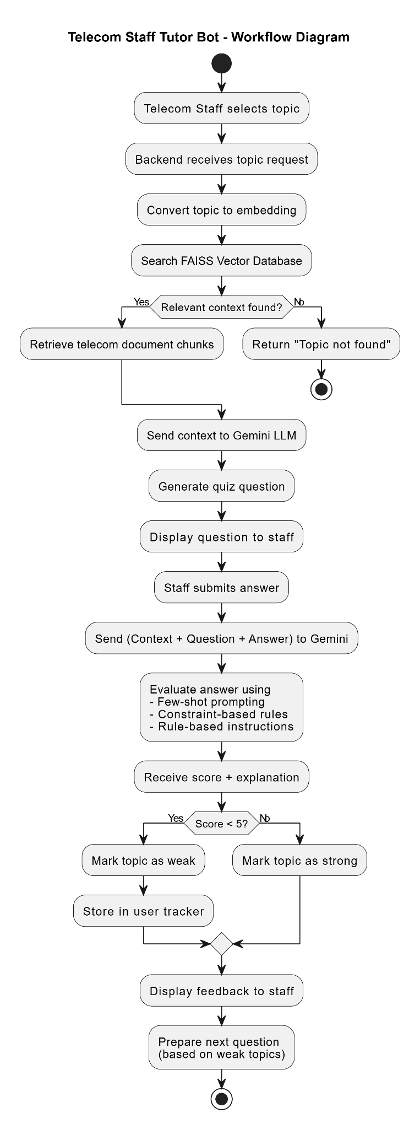

Sequence Diagram

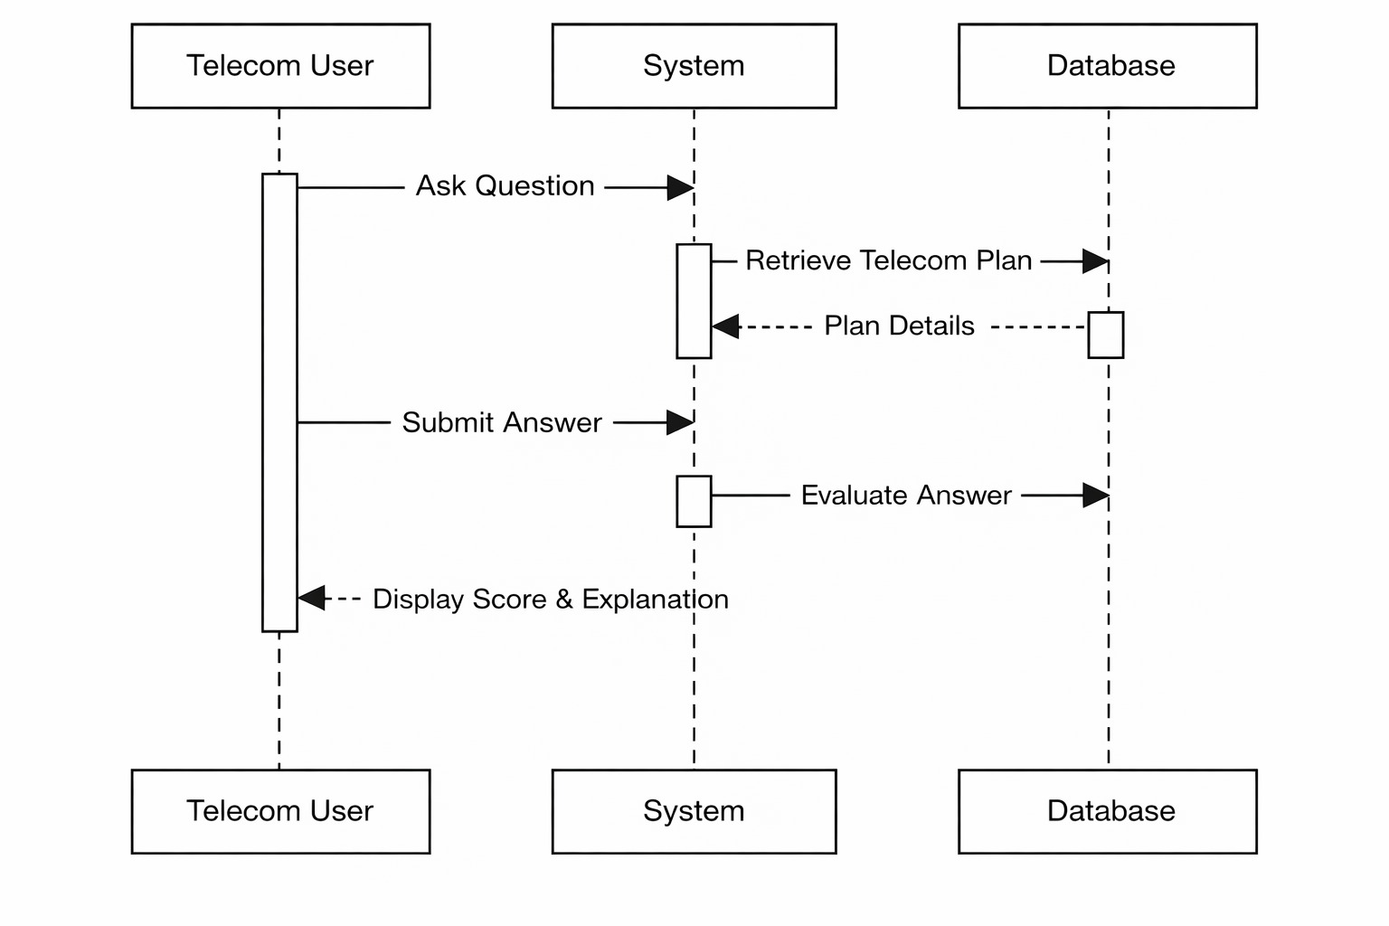

2.3 Information Flow
The information flow ensures smooth data movement between system components.

1. Input Flow
User Input → Chat Interface → Application Layer → Evaluation Engine

2. Evaluation Flow
Application Layer → Prompt Builder → LLM API → Evaluation Response

3. Feedback Flow
LLM Output → Explanation Formatter → Chat Interface → User

4. Data Storage Flow
Session Data → Performance Tracker → Database

5. Personalization Flow
Performance Data → Weak Area Detector → Adaptive Question Generator
The system maintains session state to ensure continuity while keeping AI evaluation calls independent and secure.

DataFlow Diagram :
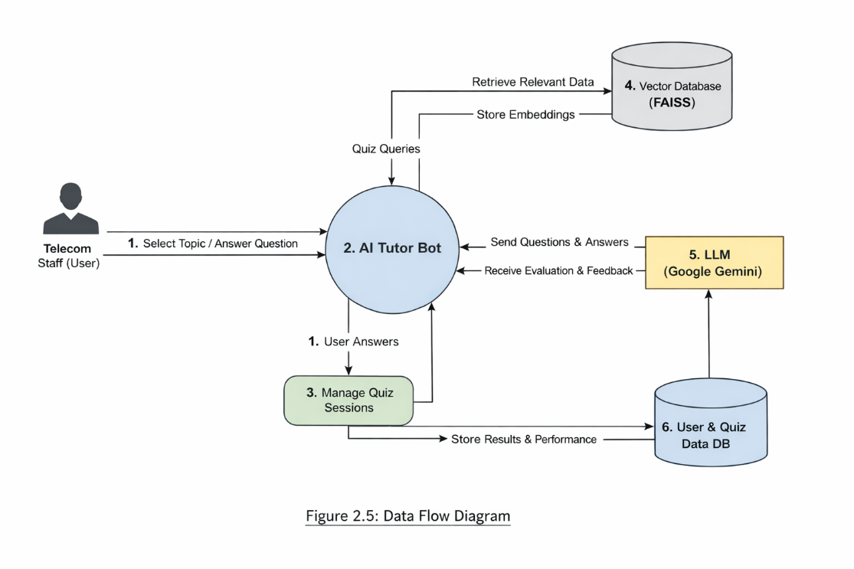

2.4 Components Design
The system consists of the following major components:

1. User Interface Module
- Chat window
- Question display
- Response input
- Feedback presentation

2. Session Manager
- Tracks user session state
- Maintains quiz progress
- Stores context

3. Question Generator
- Rule-based question templates
- AI-assisted dynamic question creation

- Difficulty-level management

4. LLM Evaluation Engine
- Prompt engineering module
- Context injection logic
- Structured output parser
- Concept gap analyzer

5. Explanation Engine
- Generates detailed reasoning
- Maps errors to telecom concepts
- Simplifies technical explanations

6. Personalization Engine
- Performance analyzer
- Weak topic detection
- Adaptive difficulty adjustment

7. Telecom Knowledge Base
- Plan details
- Policy rules
- Pricing structures
- Domain definitions

8. Data Storage System
- User data
- Performance metrics
- Audit logs

Component Diagram
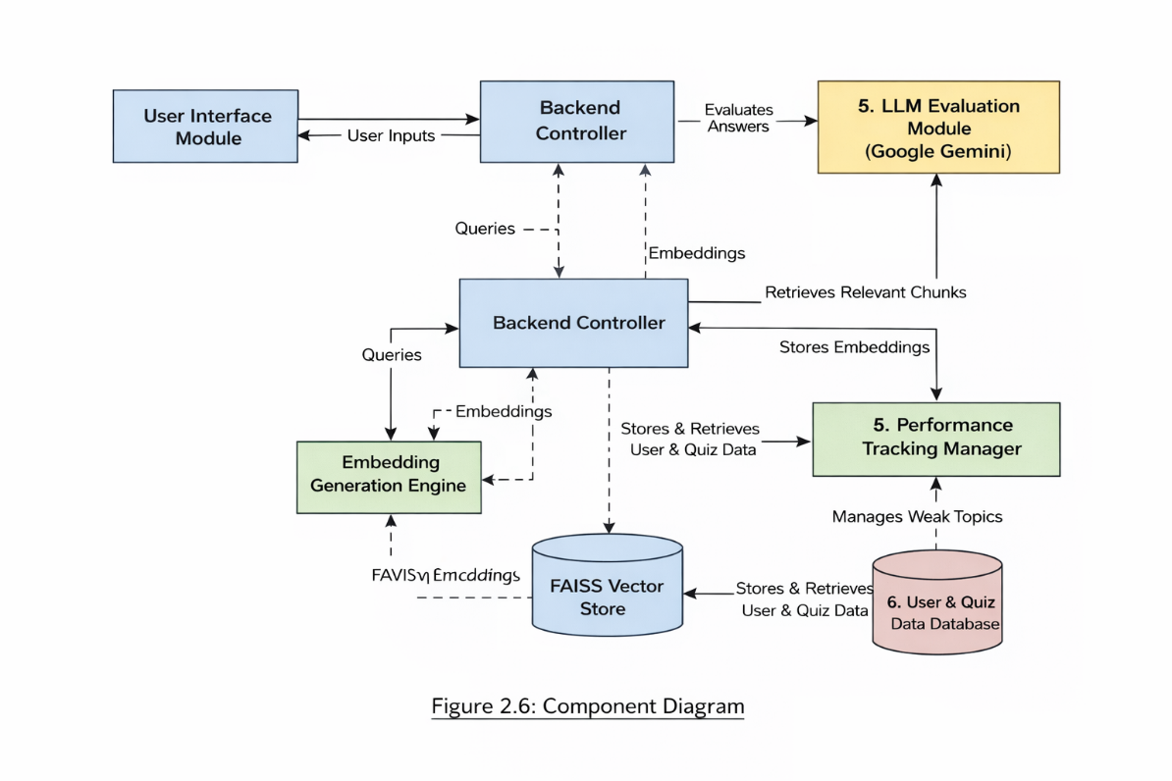

2.5 Key Design Considerations

1. Accuracy of Evaluation
- Context-based evaluation instead of keyword matching.
- Structured prompt templates for consistent LLM output.

2. Personalization
- Performance tracking per concept.
- Adaptive difficulty scaling.
- Reinforcement of weak areas.

3. Scalability
- Stateless AI API calls.
- Modular microservice-friendly architecture.
- Cloud deployment compatibility.

4. Security
- Secure API communication (HTTPS).
- Role-based access (if enterprise deployment).

- Data encryption at rest and in transit.

5. Reliability
- Fallback logic if LLM fails.
- Timeout handling.
- Logging and monitoring.

6. Maintainability
- Modular component separation.
- Configurable telecom plan datasets.
- Extensible question templates.

7. Performance Optimization
- Caching frequently used plan data.
- Response formatting optimization.
- Controlled token usage in LLM prompts.

2.6 API Catalogue
The system interacts with internal and external APIs. Below is a conceptual API catalogue:

1. Authentication API
Endpoint: /api/auth/login
Method: POST
Purpose: Authenticate user
Input: Username, Password
Output: Access token

2. Plan Retrieval API
Endpoint: /api/plans/{plan_id}
Method: GET
Purpose: Fetch telecom plan details
Output: Plan specifications (pricing, FUP, validity, roaming rules)

3. Question Generation API
Endpoint: /api/questions/generate
Method: POST
Purpose: Generate plan-based question
Input: Plan ID, Difficulty Level
Output: Question text

4. Answer Evaluation API
Endpoint: /api/evaluate
Method: POST
Purpose: Send user response for LLM evaluation
Input:
- Plan details
- Question
- User answer
Output:
- Correctness level
- Concept gap analysis
- Detailed explanation

5. Performance Tracking API
Endpoint: /api/performance/update
Method: POST
Purpose: Store user performance data

6. Personalization API
Endpoint: /api/personalize/next-question
Method: GET
Purpose: Generate adaptive follow-up question
Output: Personalized question

7. Analytics API (Optional)
Endpoint: /api/analytics/report
Method: GET
Purpose: Generate user progress report

3. Data Design
The Data Design of the Telecomm Tutor Bot defines how telecomm knowledge, embeddings, user interactions, evaluation outputs, and performance analytics are structured, stored, accessed, and maintained.
Since the system relies on:
- Telecom documents
- Embeddings (vector representations)
- Semantic search
- AI-generated evaluations
- Personalized learning tracking
a well-organized data architecture is critical for accuracy, performance, scalability, and security.
The data design supports both:
- Structured relational data (users, scores, sessions)
- Unstructured + vector data (telecom documents, embeddings)

3.1 Data Model
The system uses a hybrid data model consisting of:
- Relational Database (for structured data)
- Vector Database (for embeddings)
- File Storage (for telecom documents)
Below is the detailed data model.

Telecom Knowledge Data Model

1️. Telecom Document Entity
Stores original telecomm knowledge files.

Attributes:
- document_id (Primary Key)
- document_name
- document_type (Plan / FUP / Roaming / Billing)
- upload_date
- version
- file_path
- status (Active / Archived)

2️. Document Chunk Entity
Since large documents are split into smaller sections before embedding:
Attributes:
- chunk_id (Primary Key)
- document_id (Foreign Key)
- chunk_text
- chunk_index
- embedding_vector_id
- created_timestamp
Each chunk corresponds to:
- A paragraph
- A rule
- A specific plan section

3️. Embedding Store (FAISS Index)
Stored inside FAISS:
- embedding_vector
- associated_chunk_id
Purpose:
- Enable semantic similarity search
- Retrieve most relevant telecom content
This is not relational — it is vector-based storage.

B. User & Assessment Data Model

4️. User Entity
Attributes:
- user_id (Primary Key)
- name
- email
- department
- role (Staff / Admin)
- registration_date
- last_login

5️. Quiz Session Entity
Tracks quiz attempts.
Attributes:
- session_id (Primary Key)
- user_id (Foreign Key)
- topic_selected
- start_time
- end_time
- session_score

6️. Question Entity
Attributes:
- question_id (Primary Key)
- session_id (Foreign Key)
- retrieved_chunk_ids
- generated_question_text
- difficulty_level
- timestamp

7️. User Response Entity
Attributes:
- response_id (Primary Key)

- question_id (Foreign Key)
- user_answer
- submission_time

8. Evaluation Entity
Stores Gemini evaluation results.
Attributes:
- evaluation_id (Primary Key)
- response_id (Foreign Key)
- score (0–10)
- correctness_label (Correct / Partial / Incorrect)
- explanation_text
- identified_weak_concept
- evaluation_timestamp

9.Performance Tracking Entity
Tracks weak areas and mastery levels.
Attributes:
- performance_id
- user_id
- concept_tag
- total_attempts
- average_score
- weakness_flag (Yes/No)
- mastery_level (Low/Medium/High)

Data Relationships
- One Document → Many Chunks
- One Chunk → One Embedding
- One User → Many Sessions
- One Session → Many Questions
- One Question → One Response
- One Response → One Evaluation
- One User → Many Performance Records

3.2 Data Access Mechanism
The system ensures secure and optimized data retrieval through layered access mechanisms.

1️. Relational Database Access
Used for:
- Users
- Sessions
- Scores
- Performance tracking
Access method:
- ORM (e.g., SQLAlchemy)
- Repository pattern
- Parameterized queries
Security:
- Role-based access control
- Encrypted credentials
- Input validation

2️. Vector Database Access (FAISS)
Used for:
- Semantic search
Process:
- Convert user query into embedding
- Search FAISS index
- Retrieve top-k similar chunks
- Return chunk_text to application layer
Performance Optimization:
- In-memory FAISS index
- Indexed search for fast retrieval
- Batch embedding operations

3️. LLM Data Flow
When sending data to Gemini:
Only the following are transmitted:
- Retrieved telecom chunks
- Generated question
- User answer
Not transmitted:
- User passwords
- Sensitive internal identifiers
This ensures minimal exposure of private data.

4️. Caching Strategy
To improve performance:
- Frequently used telecom topics cached
- Active session data stored temporarily in memory
- Embeddings pre-loaded at startup

3.3 Data Retention Policies
The system follows defined retention and compliance rules.

1️. Telecom Knowledge Data
- Retained as long as active
- Version-controlled
- Archived when outdated
- Old versions retained for audit tracking

2️. User Account Data
- Stored while account is active
- Deleted upon termination request
- Inactive accounts archived after defined period

3️. Quiz & Evaluation Data
- Stored for performance tracking
- Retained for training analytics
- Archived after long inactivity (e.g., 12–24 months)

4️. Embeddings
- Regenerated when documents updated
- Old embeddings removed after re-indexing
- Backups stored securely

5️. Backup Policy
- Daily incremental backups
- Weekly full backups
- Secure cloud storage
- Periodic restore testing

6️. Compliance Considerations
- Data encryption (in transit & at rest)
- User consent for training data usage
- Right to data deletion
- Access logging and monitoring

3.4 Data Migration
Data migration ensures smooth system updates and scalability.

1️. Initial Migration
When system is deployed:
- Import telecom documents (PDF)
- Clean and preprocess text
- Split into chunks
- Generate embeddings
- Store in FAISS

2️. Plan Update Migration
When telecom plans change:
- Upload updated document

- Re-chunk text
- Regenerate embeddings
- Replace FAISS index
- Archive old version

3️. Schema Evolution
If database structure changes:
- Use migration tools
- Version-controlled schema updates
- Backward compatibility maintained

4️. User Data Migration
If upgrading system:
- Export user data
- Validate integrity
- Re-import into new schema
- Perform verification checks

5️. Rollback Strategy
Before any migration:
- Full backup taken
- Snapshot of database stored
- FAISS index backed up
- Restore procedure tested

4. Interfaces
This section describes the various interfaces through which the Telecomm Tutor Bot interacts with users, external systems, databases, and AI services. Interfaces define how different system components communicate with each other and ensure smooth data exchange.

The system includes:
- User Interface
- Application Programming Interfaces (APIs)
- External AI Service Interfaces

- Database Interfaces
- Administrative Interfaces

4.1 User Interface (UI)
The User Interface provides interaction between telecomm staff and the AI Tutor Bot.

Interface Type:
- Web-based interface (Browser)
- Optional Mobile-responsive interface

Functional Capabilities:
- Topic selection
- Quiz initiation
- Answer submission
- Viewing evaluation results
- Viewing detailed explanations
- Performance tracking dashboard

Input:
- Topic selection
- Natural language answers

Output:
- Generated quiz questions
- Score (0–10)
- Correct/Incorrect label
- Concept explanation
- Personalized follow-up questions
The UI communicates with the backend via REST APIs using HTTPS.

4.2 Backend API Interface
The backend exposes RESTful APIs that connect the UI with system logic.

Key API Categories:
- Authentication APIs
- Quiz Management APIs
- Evaluation APIs
- Performance Tracking APIs
- Admin APIs (Document upload, re-indexing)
All APIs use:
- JSON request/response format
- Token-based authentication
- Secure HTTPS protocol

4.3 LLM Interface (Google Gemini API)
The system integrates with Google Gemini for:
- Question generation
- Answer evaluation
- Explanation generation

Communication Method:
- HTTPS API call
- Structured prompt format

Input Sent to Gemini:
- Retrieved telecomm context
- Generated question
- User answer
- Evaluation rules

Output Received:
- Score
- Correctness label
- Explanation
- Identified weak concept
The system ensures:
- No sensitive user data is shared

- Strict prompt constraints to avoid hallucination

4.4 Vector Database Interface (FAISS)
The backend communicates with FAISS for semantic search.

Interface Purpose:
- Store embeddings
- Retrieve relevant telecom chunks

Process:
- Convert query into embedding
- Perform similarity search
- Retrieve top-k relevant chunks
FAISS operates as an internal service within the backend environment.

4.5 Embedding Model Interface (Hugging Face)
Used to convert telecom documents and user queries into embeddings.

Input:
- Telecom text chunks
- Query text

Output:
- Vector embeddings
This interface is accessed via Python integration or API calls.

4.6 Database Interface (User & Quiz Database)
The system connects to a relational database to store:
- User data
- Quiz sessions
- Scores
- Evaluation results

- Performance metrics

Access Method:
- ORM layer
- Secure credential management
- Role-based access control

4.7 Administrative Interface
Provides management capabilities for administrators.

Admin Capabilities:
- Upload telecom documents
- Trigger embedding generation
- Rebuild FAISS index
- View analytics reports
- Manage user accounts

5. State and Session Management
This section describes how the Telecomm Quiz manages user sessions, application state, quiz progress, and personalized learning data throughout system interaction.
Since the system is interactive and AI-driven, maintaining proper session tracking and state consistency is critical for delivering personalized and continuous learning experiences.

5.1 Session Management
A session represents a continuous interaction between a telecom staff member and the system during a quiz or learning activity.

5.1.1 Session Creation
A session is created when:
- A user logs into the system, or
- A user starts a new quiz
Each session is assigned a unique Session ID.

5.1.2 Session Attributes
Each session stores:
- Session_ID
- User_ID
- Selected Topic
- Start Time
- Current Question ID
- Current Score
- Weak Topics Identified

5.1.3 Session Lifecycle
- Session Initiation
User selects topic → Session created.
- Active Session
- Question generated
- Answer submitted
- Evaluation performed
- Score updated
- Session Completion
- Final score calculated
- Performance stored
- Session marked completed
- Session Expiry
- Automatic timeout after inactivity
- Session closed securely

5.1.4 Session Timeout Policy
To ensure security and performance:
- Inactivity timeout (e.g., 15–30 minutes)
- Automatic session invalidation
- Token-based session validation

5.2 Application State Management
State refers to the current condition of user interaction within the system.
The Telecomm Tutor Bot maintains two types of state:

5.2.1 Client-Side State
Stored temporarily in:
- Browser memory
- Session storage
Includes:
- Current question display
- Temporary user input
- UI navigation state

5.2.2 Server-Side State
Maintained in backend/database.
Includes:
- Quiz progress
- Retrieved telecom context
- Evaluation results
- Performance tracking
Server-side state ensures consistency even if user refreshes the page.

5.3 Quiz State Tracking
The system tracks quiz progression using:
- Question number
- Attempt count
- Topic difficulty level
- Cumulative score
After each evaluation:

- Score is updated
- Weak topic detection logic runs
- Personalization engine adjusts next question

5.4 Personalization State
Personalization data is persistent across sessions.
Stored data includes:
- Concept-wise performance
- Weak area flags
- Average score per topic
- Mastery level
This allows:
- Adaptive difficulty
- Reinforcement of weak concepts
- Intelligent question sequencing

5.5 Token and Authentication Management
Authentication uses:
- Secure login mechanism
- Access tokens (JWT or session tokens)
- Encrypted credentials
Token Features:
- Expiry time
- Role-based authorization
- Secure transmission over HTTPS

5.6 LLM Interaction State
The system maintains controlled context when communicating with the AI model:
- Only relevant retrieved chunks are sent
- No full session history exposed
- Structured prompt format used
LLM calls are stateless, but session context is managed at the backend.

5.7 Error and Recovery Handling
If system failure occurs during session:
- Partial progress is stored
- Session can resume from last completed question
- Evaluation logs preserved
This ensures continuity and reliability.

6. Caching
Caching is implemented in the Telecomm Quiz/Tutor Bot to improve system performance, reduce response time, optimize AI calls, and minimize repeated database and vector search operations.
Since the system performs semantic search and LLM evaluations, caching plays a critical role in improving efficiency and scalability.

6.1 Purpose of Caching
The primary objectives of caching in this system are:

- Reduce repeated FAISS search operations
- Minimize repeated LLM prompt generation
- Improve response speed for users
- Reduce API cost for LLM calls
- Decrease database load
- Enhance scalability during multiple concurrent sessions

6.2 Types of Caching Used
The system uses multiple caching strategies:

6.2.1 Telecom Content Cache
Frequently accessed telecom documents or topic chunks are cached.

What is Cached:
- Retrieved telecom document chunks
- Embedding results for common queries
- Top-k search results

Benefit:
- Avoid repeated semantic search
- Faster quiz question generation

6.2.2 Embedding Cache
If the same document or query embedding is generated multiple times:
- The system stores embedding results temporarily
- Reuses embeddings instead of recomputing

Benefit:
- Reduces Hugging Face model calls
- Improves performance

6.2.3 LLM Response Cache
If identical:
- Topic
- Context
- Question

are requested again, the system may cache generated question templates or explanations.
Note:
Evaluation of user answers is typically not cached since answers vary.

6.2.4 Session-Level Cache
During an active quiz session:
- Retrieved telecom chunks
- Current question
- Evaluation results
are temporarily stored in memory to avoid repeated retrieval.

6.2.5 Performance Analytics Cache
Frequently accessed analytics such as:
- Average user score
- Weak topic summaries
- Dashboard statistics
are cached to improve dashboard loading speed.

6.3 Cache Storage Mechanism
The system may use:
- In-memory caching (Python dictionaries)
- Redis (for distributed caching in production)
- Application-level caching
For small-scale deployment:
- In-memory cache is sufficient
For enterprise deployment:
- Redis or similar distributed cache is recommended

6.4 Cache Expiration Policy
To ensure data consistency:
- Telecom content cache invalidated when document updates occur
- Embedding cache refreshed after re-indexing

- Session cache cleared after session expiry
- Analytics cache refreshed periodically
Example Policies:
- Session Cache → 30 minutes
- Content Cache → Until document update
- Analytics Cache → 5–15 minutes

6.5 Cache Invalidation Strategy
Cache is invalidated when:
- New telecom document is uploaded
- FAISS index is rebuilt
- Plan details are modified
- User logs out
- Session times out
Proper invalidation prevents outdated telecom data from being used.

6.6 Security Considerations in Caching
To maintain security:
- Sensitive user credentials are never cached
- Authentication tokens are securely handled
- Cached data is cleared upon logout
- Redis access is restricted with authentication

6.7 Performance Benefits
With caching enabled, the system achieves:
- Faster quiz generation
- Reduced LLM API calls
- Lower operational cost
- Improved user experience
- Better scalability for multiple users

7. Non-Functional Requirements
Non-Functional Requirements (NFRs) define the quality attributes of the Telecomm Tutor Bot. These requirements ensure the system is secure, reliable, scalable, and efficient while delivering AI-driven personalized training.

7.1 Security Aspects
Security is critical since the system handles:
- User information
- Training data
- Performance analytics
- API integrations with external AI services
The following security measures are implemented:

7.1.1 Authentication & Authorization
- Secure login mechanism
- Token-based authentication (JWT/session tokens)
- Role-based access control (Staff / Admin)
- Session timeout after inactivity

7.1.2 Data Encryption
- HTTPS encryption for all API communication
- Encryption of sensitive data at rest
- Secure storage of API keys and credentials

7.1.3 Secure API Integration
- Gemini API keys stored securely in environment variables
- No exposure of internal system data to external APIs
- Only required telecom context sent to LLM
- Strict prompt control to prevent misuse

7.2 Performance Aspects
The system must handle multiple users efficiently while maintaining fast response times.

7.2.1 Response Time
- Quiz question generation within 2–4 seconds
- Answer evaluation within 3–6 seconds

7.2.2 Scalability
- Modular architecture
- Stateless LLM API calls
- Caching mechanisms for optimization
- Support for horizontal scaling

7.2.3 Availability
- Error handling and fallback logic
- Graceful failure management

7.2.4 Load Handling
- Efficient FAISS indexing for fast semantic search
- Optimized embedding generation
- Reduced LLM token usage

8. References
The following references were used for designing and implementing the Telecomm Quiz/Tutor Bot:
- Hugging Face Documentation – Embedding Models
https://huggingface.co/docs
- FAISS Documentation – Facebook AI Similarity Search
https://faiss.ai
- Google Gemini API Documentation
https://ai.google.dev
- Python Official Documentation
https://docs.python.org
- REST API Design Best Practices
https://restfulapi.net
- UML Modeling Standards
Object Management Group (OMG) – UML Specification
- AI Prompt Engineering Best Practices
OpenAI & Google AI Documentation

